

ARTI 502
Deep Learning: 1st Assignment
Training-Testing Neural Net with MNIST Dataset using Pytorch

Year 2026 Term 1

Grade: 7.5/7.5 (according to the rubric grading) With a final accuracy of:98.44% after tuning

Group #6

Group Members:
Member | ID
Hashim Ali Aljarrash | 2230000215
Ahmad Muhanna | 2230006180
Mohammed Alammari | 2230003182
Ali Alshehri | 2230002515
Osama Al Haddaf | 2230001201

Overview

In this assignment, you will perform Training Neural Net on the MNIST Dataset dataset using Pytorch. The goal is to explore the Basic Neural Network, understand its structure, and identify important issues such as architecture, learning rate, momentum and other parameters. You will also analyze relationships between number of layers and number of neurons for each layers to the overall Neural Network performance through their tuning hyperparameters.

Objective

Explore the dataset using PyTorch to understand:

• Simple Neural Networks structure

• How to do Training-Testing Neural Networks

• How to evaluate the performance

• How to determine learning rate, momentum and model hyperparameters

Tasks (with PyTorch)

Task 1: Install PyTorch

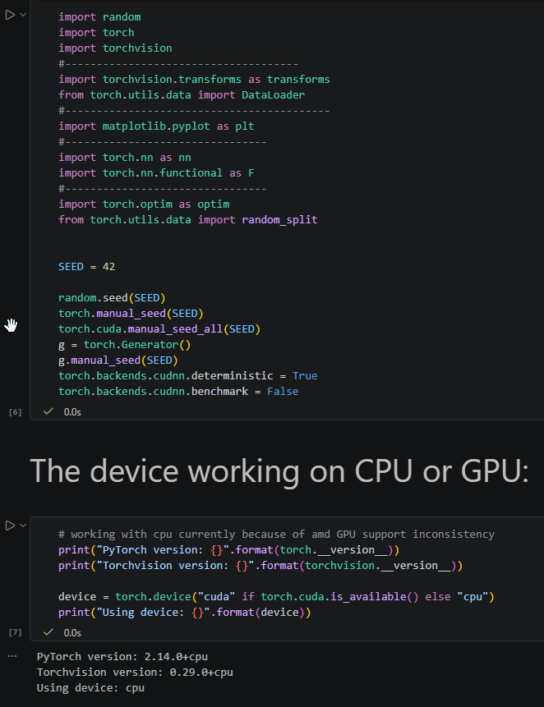

Task 2: Download and Load the Dataset

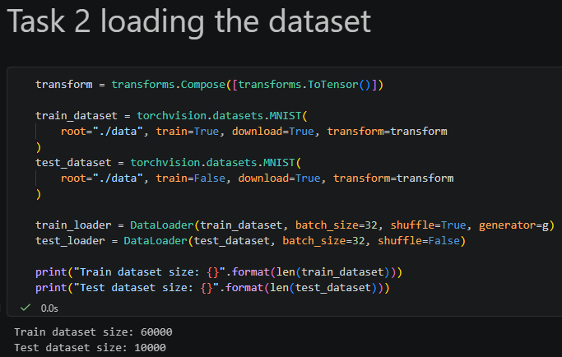

Task 3: Inspect the Dataset

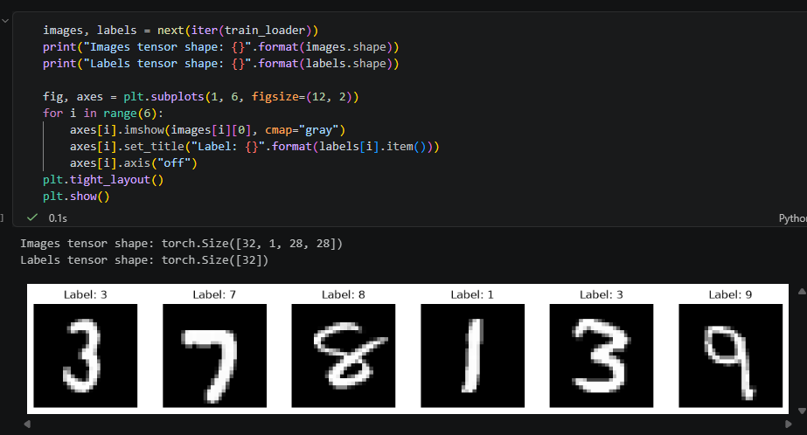

Task 4: Creating A Simple Network

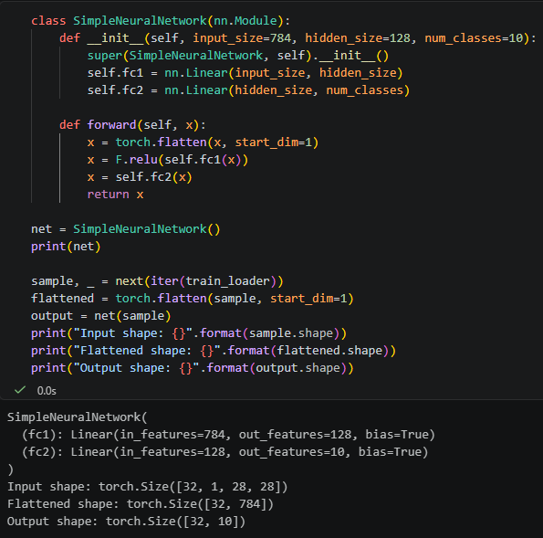

Task 5: Training Function
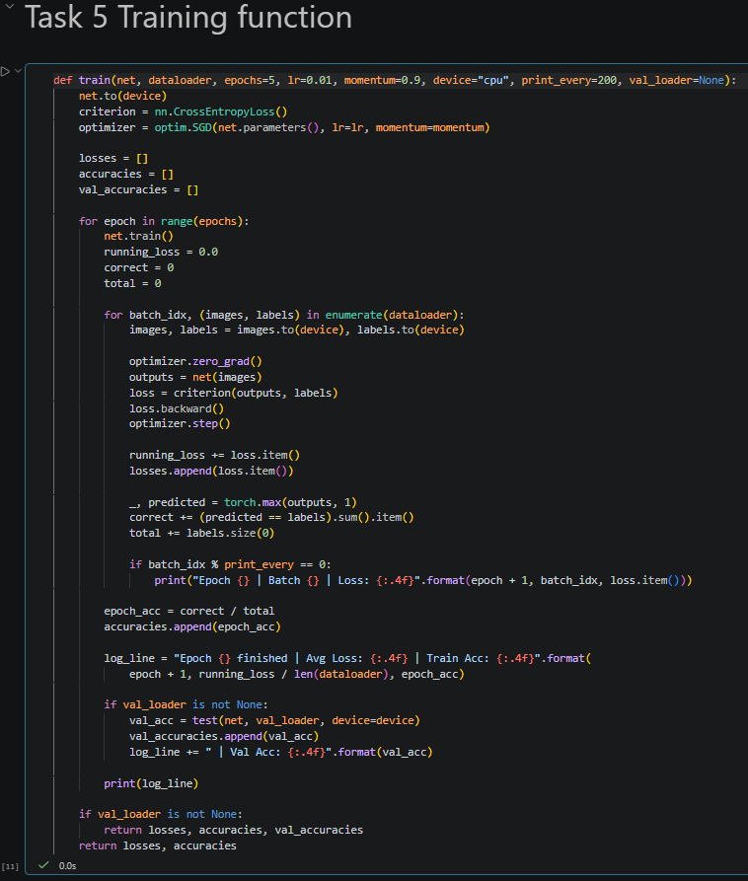

Task 6: Training Network
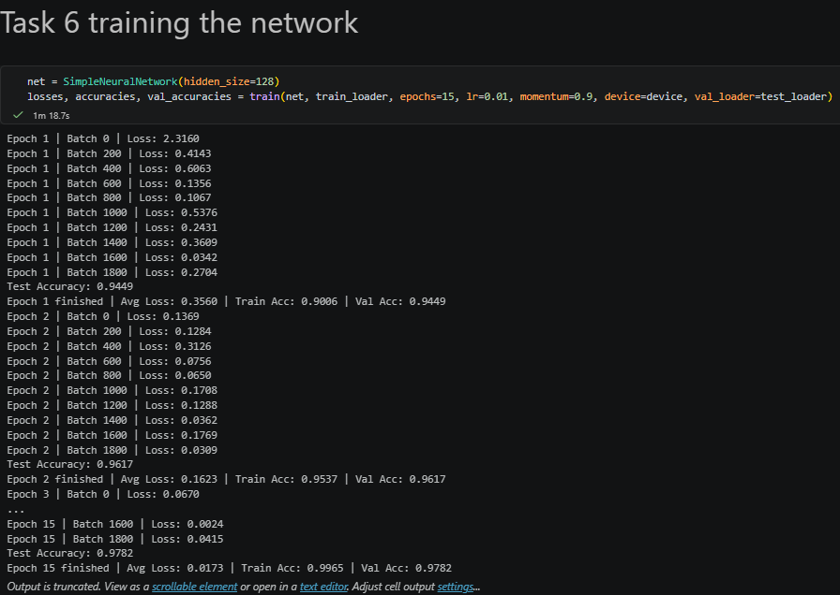

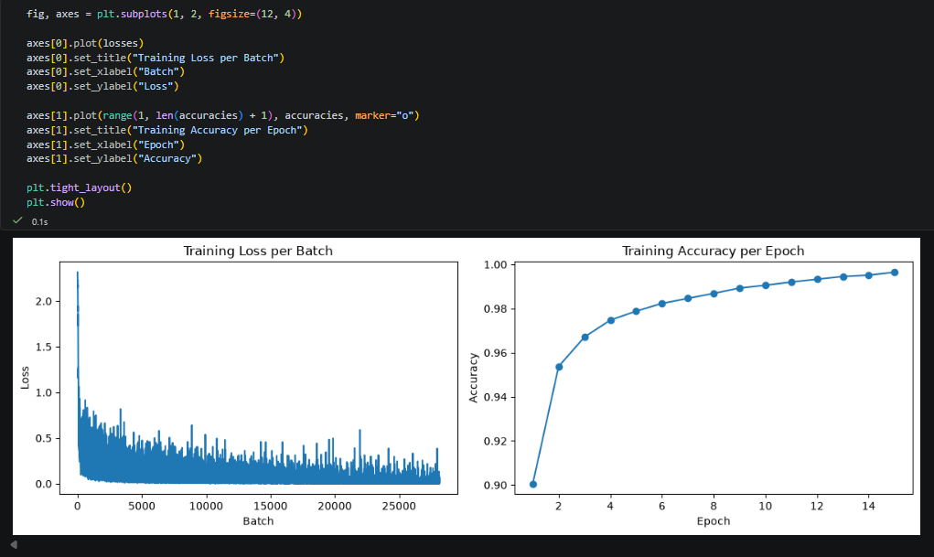

Task 7: Testing Network

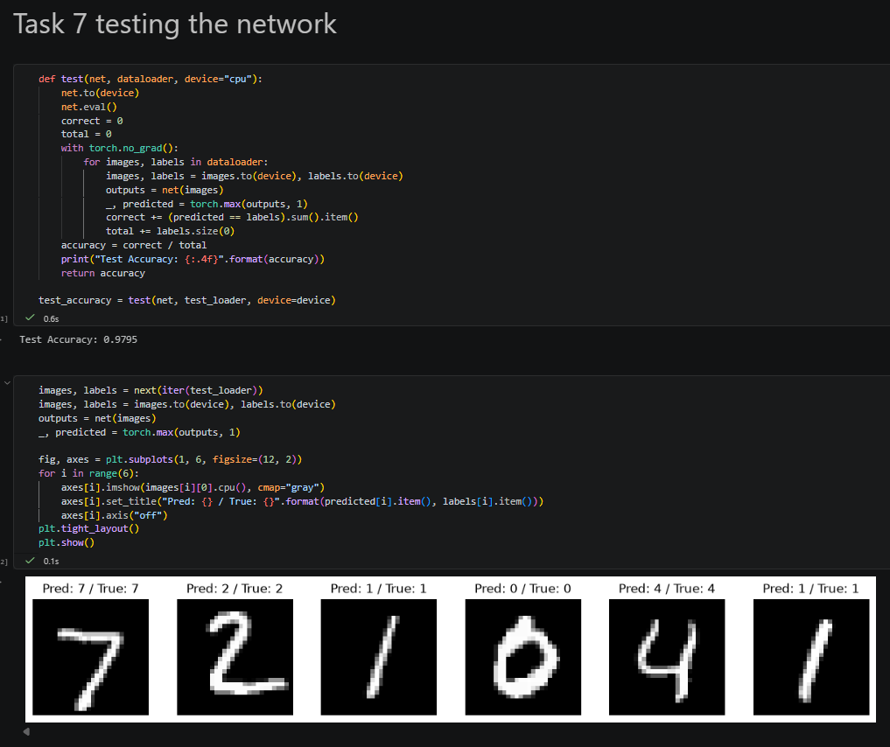

Task 8: Tuning the parameters and model archirecture

A. Tuning the learning rate and momentum:
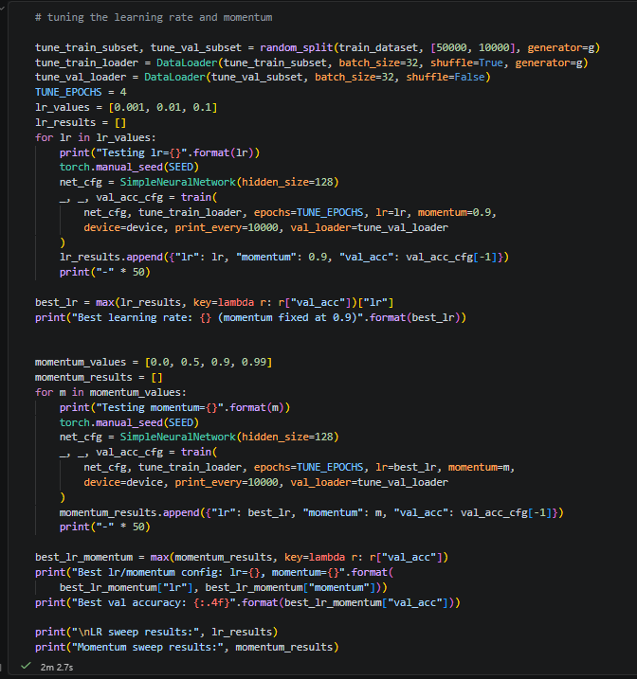

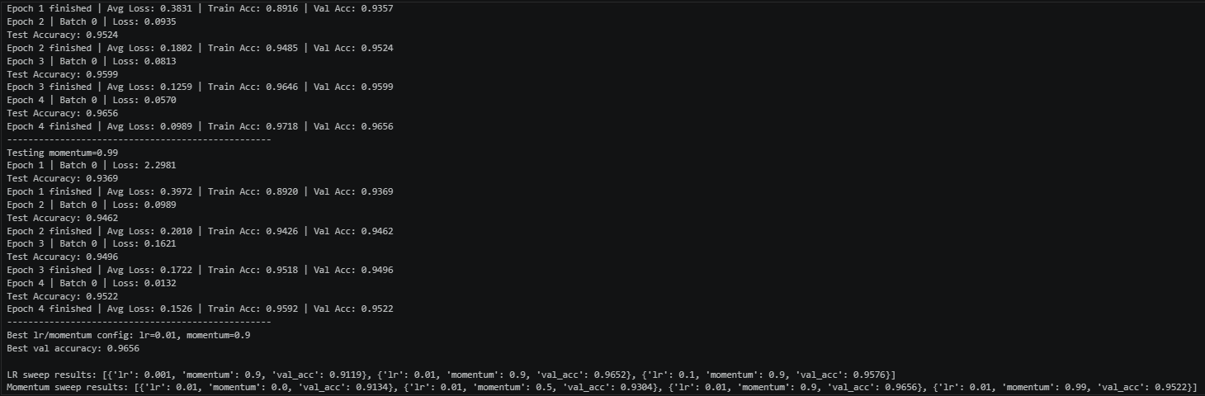
Best learning rate and momentum configuration: lr=0.01, momentum=0.9 with accuracy of 0.9656

B. tuning the architecture (number of hidden layers and neurons):
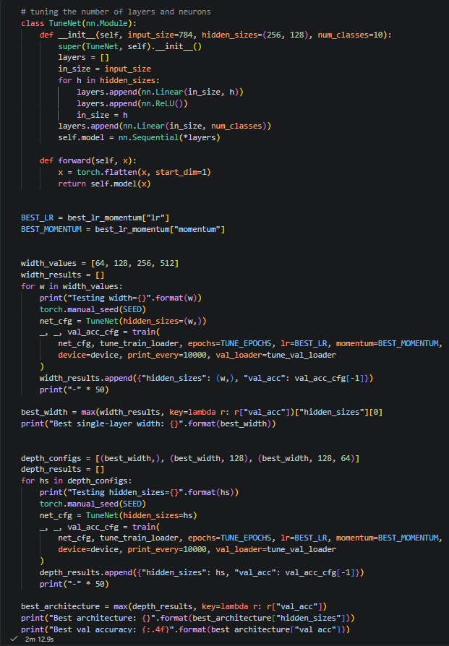

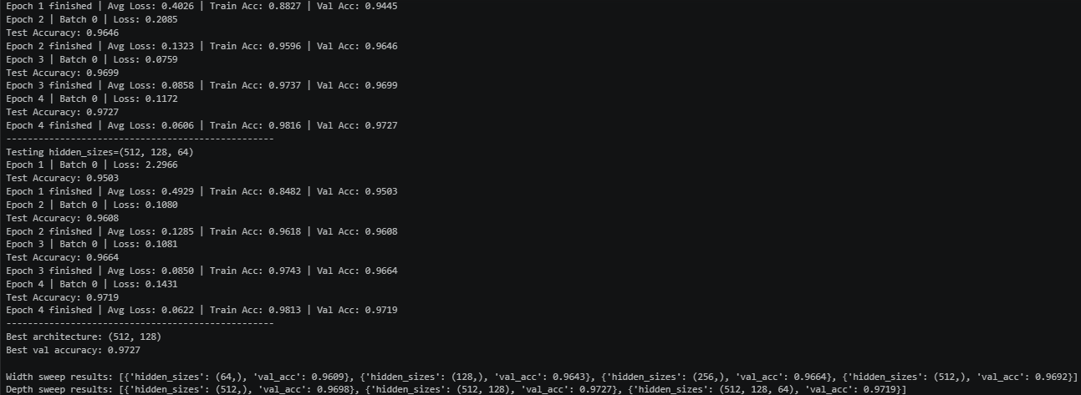
Best architecture configuration: 2 hidden layers with neurons of sizes (521, 128) at an accuracy of 0.9727

And a final test, we trained the model with the optimal/best configurations after hyper-tuning:
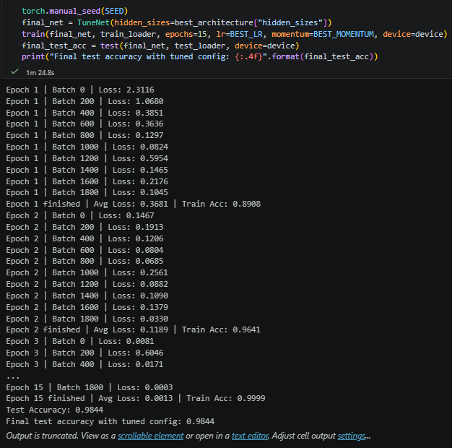

Task 9: Save your source code

GITHUB LINK

- End of Assignment -

Grading Rubric

Criterion Task 1: Install PyTorch
Excellent PyTorch installed successfully and PyTorch loaded correctly with clear structure
Good Installed and PyTorch loaded with minor issues
Developing pyTorch exists but unclear or incomplete
Poor Marks Not 0.5 completed /
missing

Task 2: Download and Load the Dataset

Task 3: Inspect the Dataset

Task 4: Creating A Simple Network

Task 6: Training Function

Task 7: Testing Network

Task 8: Tuning the parameters and model archirecture

Task 9: Save your source code
Dataset loaded correctly with clear screenshot showing successful execution
All clear screenshots

A simple network correctly craeted, screenshot included

Training function configured correctly with clear screenshots of output

Correct Testing network created, screenshot included.

Tuning parameters and model architecture created, screenshot included, and reults description explained accurately
Source code save succefully
Loaded correctly but screenshot is unclear

Minor mistakes or missing small details

Minor reporting issues

Minor reporting issues

Testing network correct but result description is weak
Tuning Parameters and model architecture correct but results description is weak
Source code save succefully done but minor missing item
Total
Dataset loaded with issues or incomplete evidence

Several missing description or unclear screenshots

Node used but missing result explanation or screenshot

Training Function used but missing result explanation or screenshot Testing network exists but unclear results description

Tuning Parameters and model architecture corect but incorrect results description

Source code save incomplete or file format incorrect
Not loaded 0.5 / missing screenshot

Not 0.5 answered / incorrect / missing
evidence
Not done 2

Not done 1

Not done 1

Not done 1.5

Not 0.5 submitted / missing

7.5

